**DAILY ONLINE ACTIVITIES SUMMARY**

|  |  |  |  |  |  |  |  |  |
| --- | --- | --- | --- | --- | --- | --- | --- | --- |
| **Date:** | **24/07/2020** | | | | | **Name:** | **Spoorthy Balaji** | |
| **Sem & Sec** | **6th & B** | | | | | **USN:** | **4al17cs098** | |
| **Online Test Summary** | | | | | | | | |
| **Subject** | | **SSCD IA Module 4** | | | | | | |
| **Max. Marks** | | **30** | | **Score** | | | **-** | |
| **Certification Course Summary** | | | | | | | | |
| **Course** | **Introduction to CSS3** | | | | | | | |
| **Certificate Provider** | | | **Coursera** | | **Duration** | | | **4 Weeks** |
| **Coding Challenges** | | | | | | | | |
| **Problem Statement:  Python Program for Difference between sums of odd and even digits** | | | | | | | | |
| **Status: Solved** | | | | | | | | |
| **Uploaded the report in Github** | | | | | **yes** | | | |
| **If yes Repository name** | | | | | <https://github.com/spoorthybalaji/Daily_Status> | | | |
| **Uploaded the report in slack** | | | | | **yes** | | | |

**ONLINE COURSE**

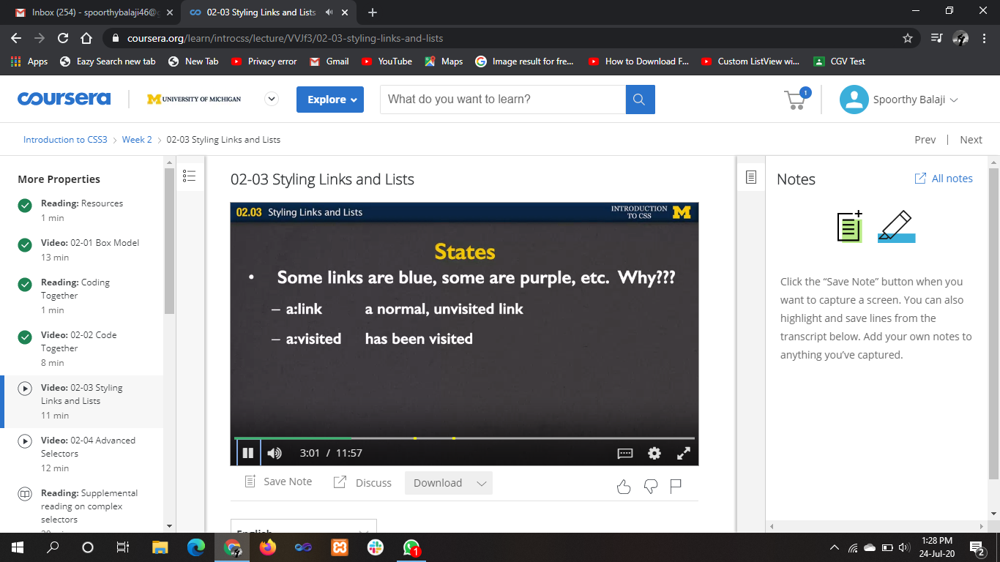

**ONLINE** **CODING**

**Python Program for Difference between sums of odd and even digits**

def isDiff(n):

return (n % 11 == 0)

n = 1243;

if (isDiff(n)):

print("Yes")

else:

print("No")

